Maths – Thursday 25th February
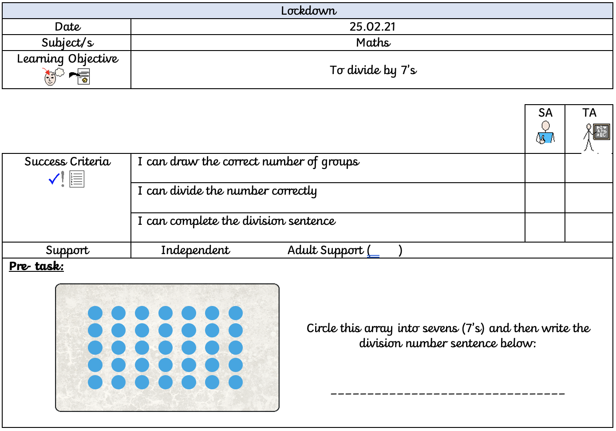
When dividing by 7, we share the given number into equal groups of seven. For example:
Here is my group of seven, and I have divided the number 21 into the circles by placing one cube into a group at a time.
This has then given me the answer of:
21 ÷ 7 = 21
Now have a go at the below.

42 ÷ 7 =
56 ÷ 7 =

28 ÷ 7 =
63 ÷ 7 =

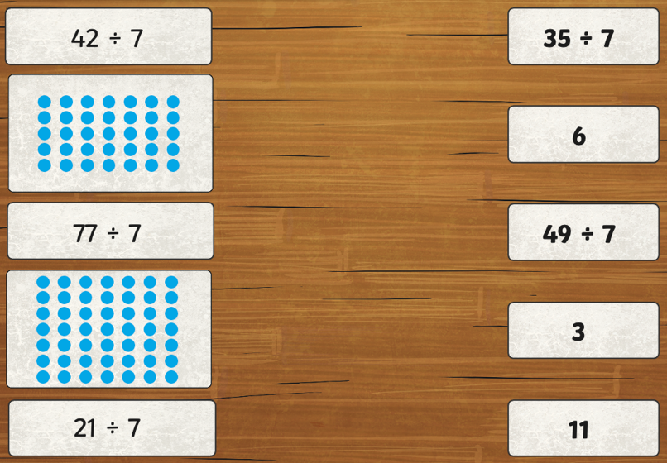
Match the answers.

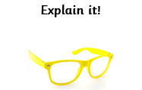
Which one is the odd one out?
Explain your answer.
80 ÷ 7 = 10
14 ÷ 7 = 9
84 ÷ 7 = 12
7 ÷ 49 = 7
100 ÷ 10 = 7

