Maths – Wednesday 3rd March
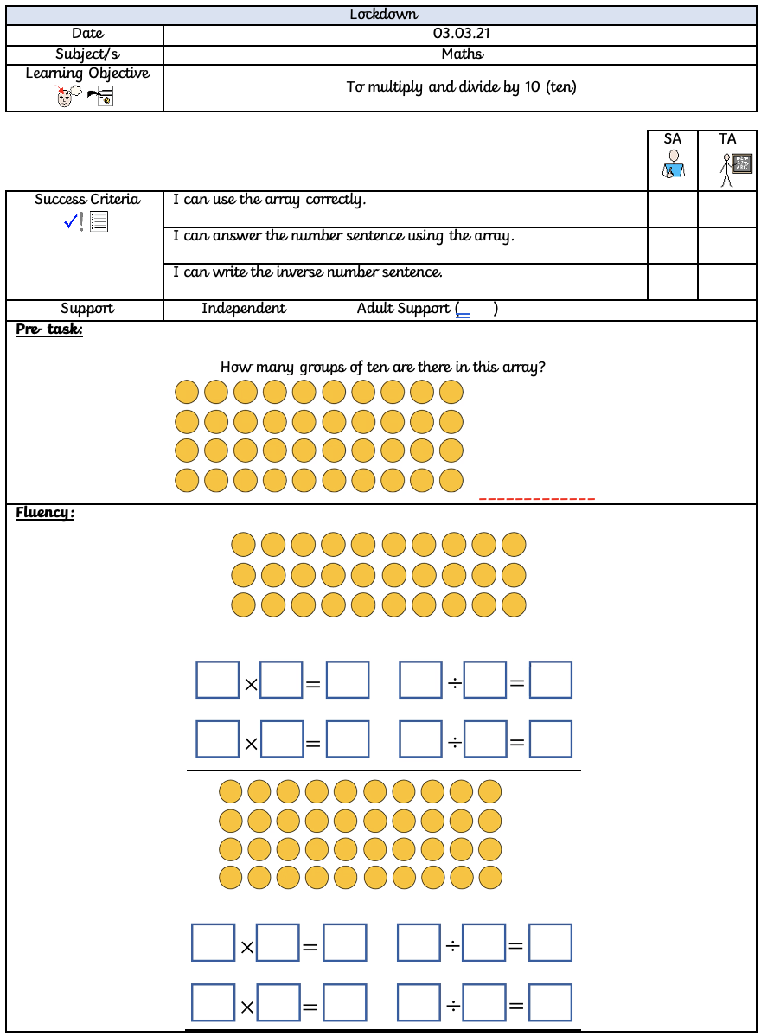

On the squared paper below, you need to draw the given arrays and then write all of the number sentences for each. One of the number sentences will be in to help you.
2 x 10 = | 5 x 10
1 x 10 | 6 x 10

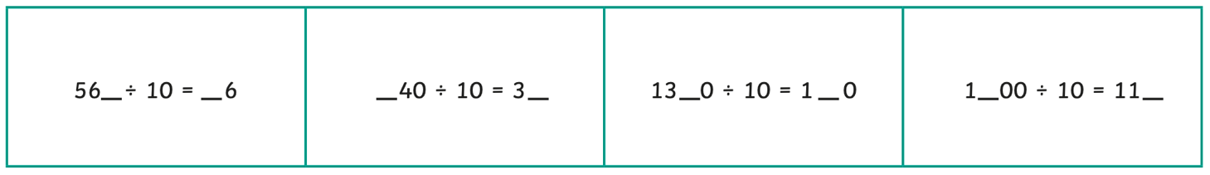
z
Complete these number sentences:

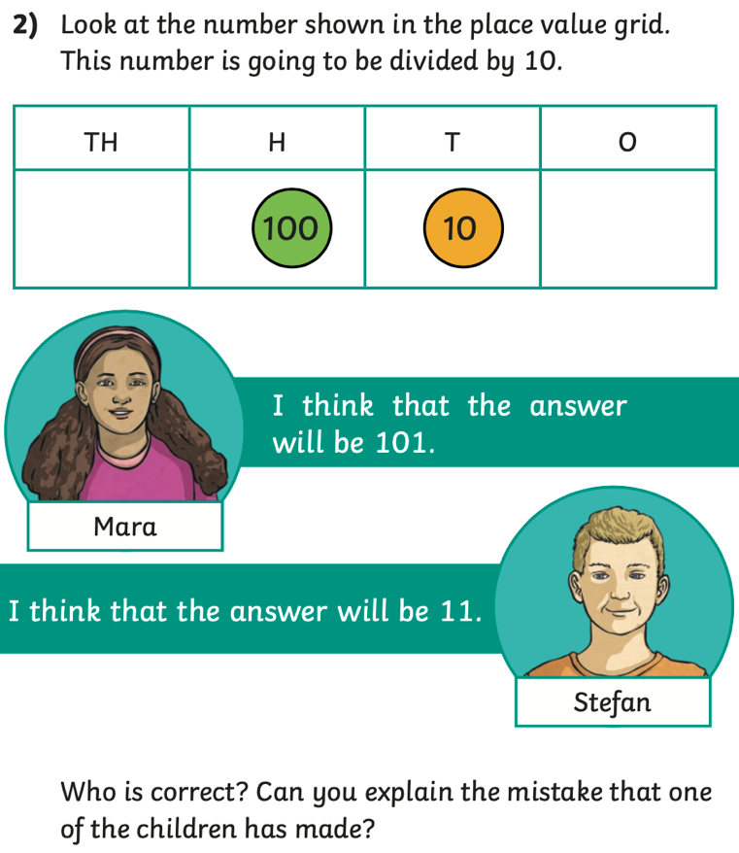
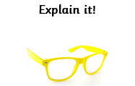
z

