Maths – Tuesday 2nd March
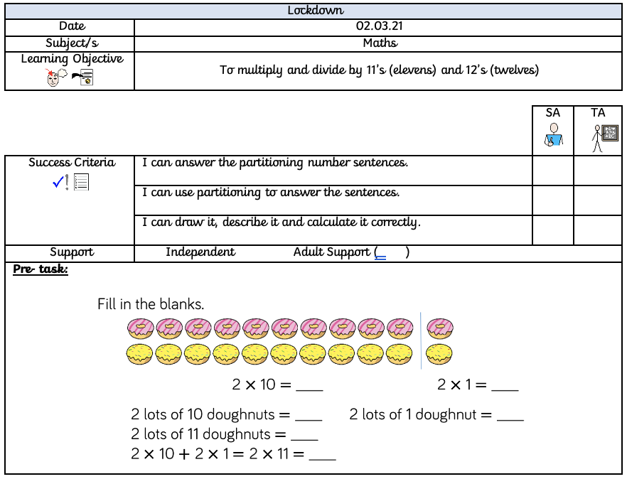
When dividing by eleven (11) and twelve (12), it can be easier to partition the number.
So, work out 2 x 10 first, and then 2 x 1 and then add them together to find out what 11 x 2 equals.
Have a go at partitioning the number to work out the answer in the fluency below:

Fluency:
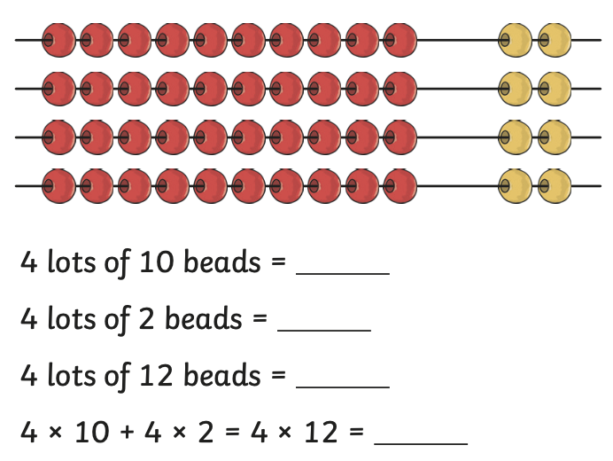

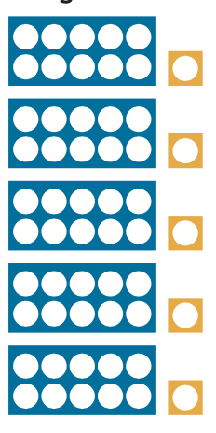

5 lots of 10 beads = _____________

5 lots of 1 bead = _____________

5 lots of 11 beads = ____________

5 x 10 + 5 x 2 = 5 x 11 = _____________

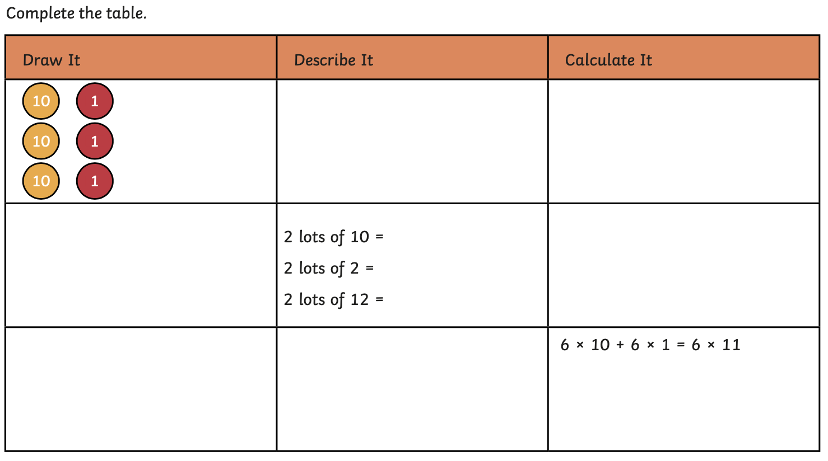
Challenge:

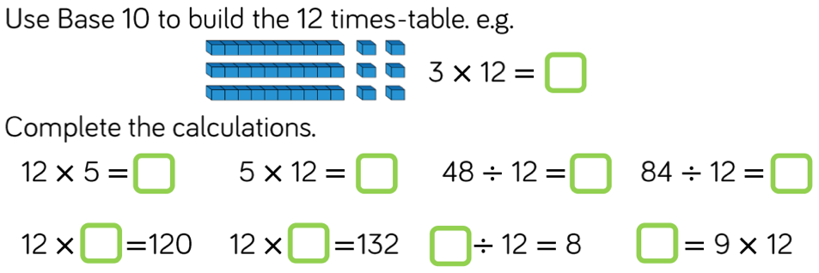
z

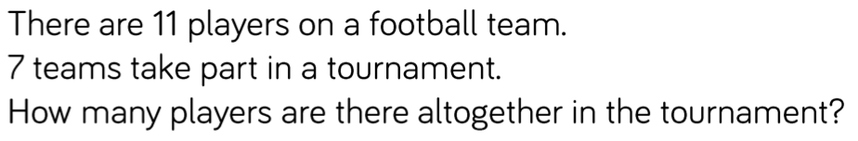

I calculated that there will be 88 players.
Convince me that I am wrong.

