Maths – Monday 1st March
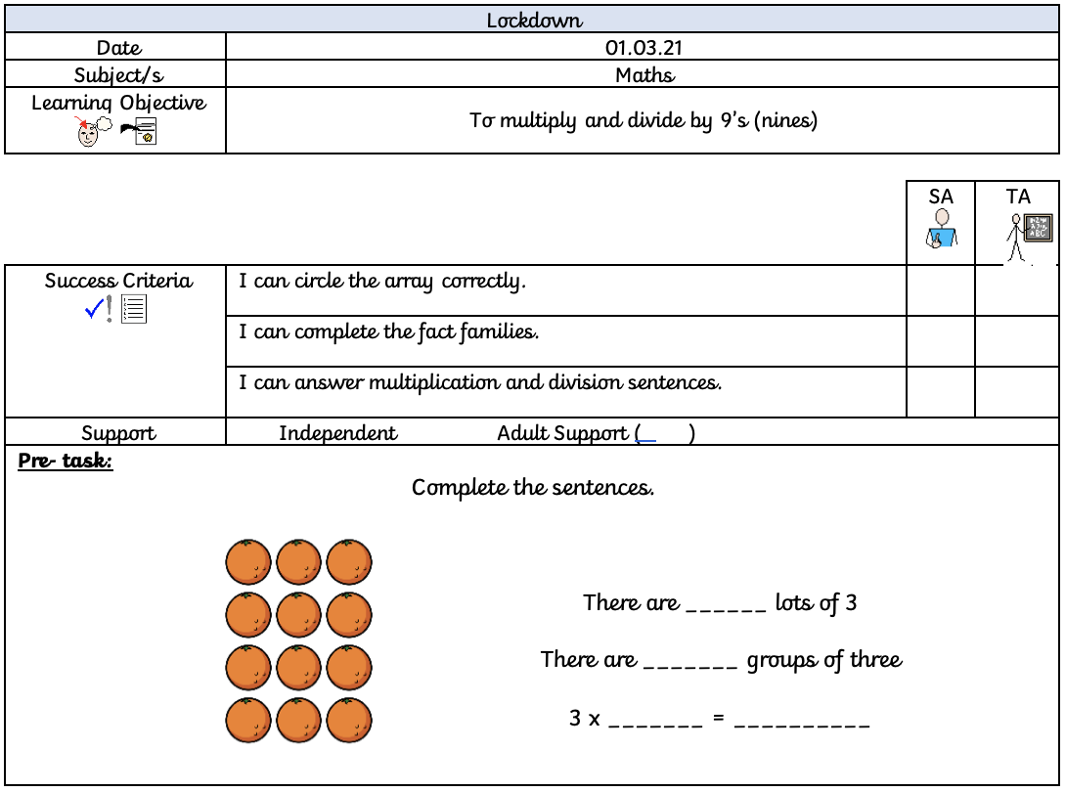
For the pre-task, circle the oranges into groups of threes (3). Then answer the questions next to it.

For fluency, you need to use the pictures of the resources to work out the answers to the number sentences. For example:
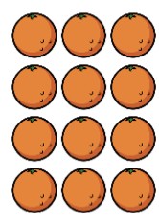
REMEMBER:
The multiplication number sentences will have the biggest number at the end.
The division number sentence will have the biggest number at the start.
3 x 4 = 12
4 x 3 = 12
12 ÷ 4 = 3
12 ÷ 3 = 4

Fluency:
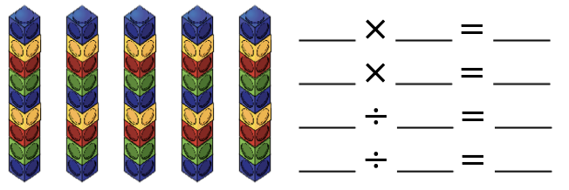

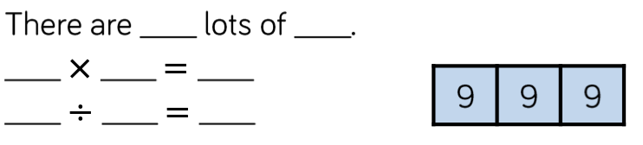

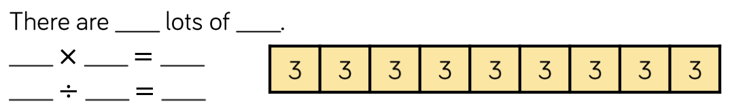

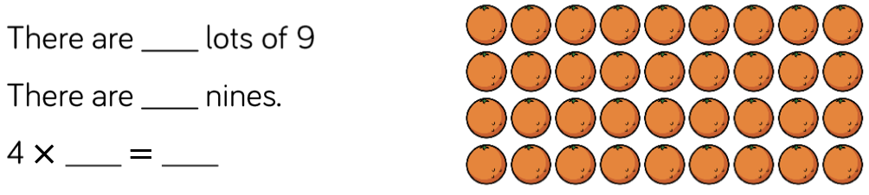

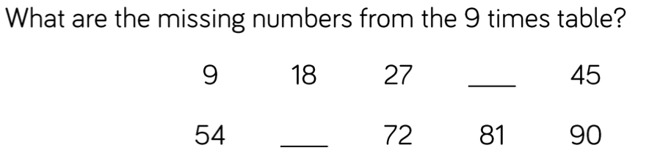
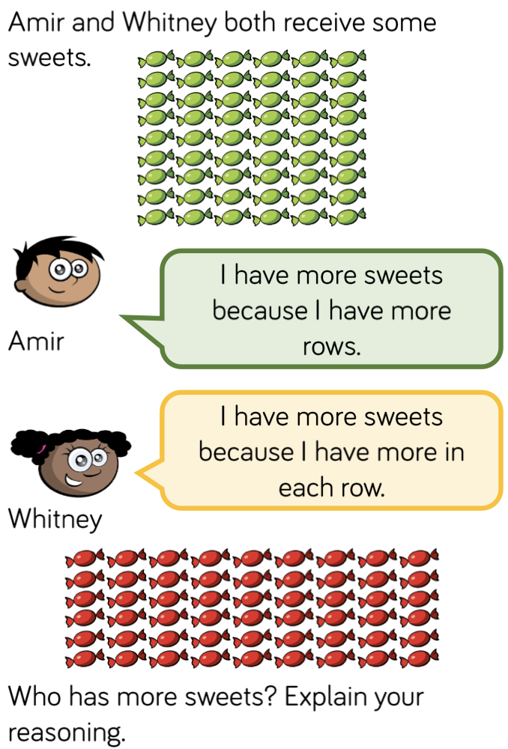
Show your working out.

