Maths – Monday 22nd February
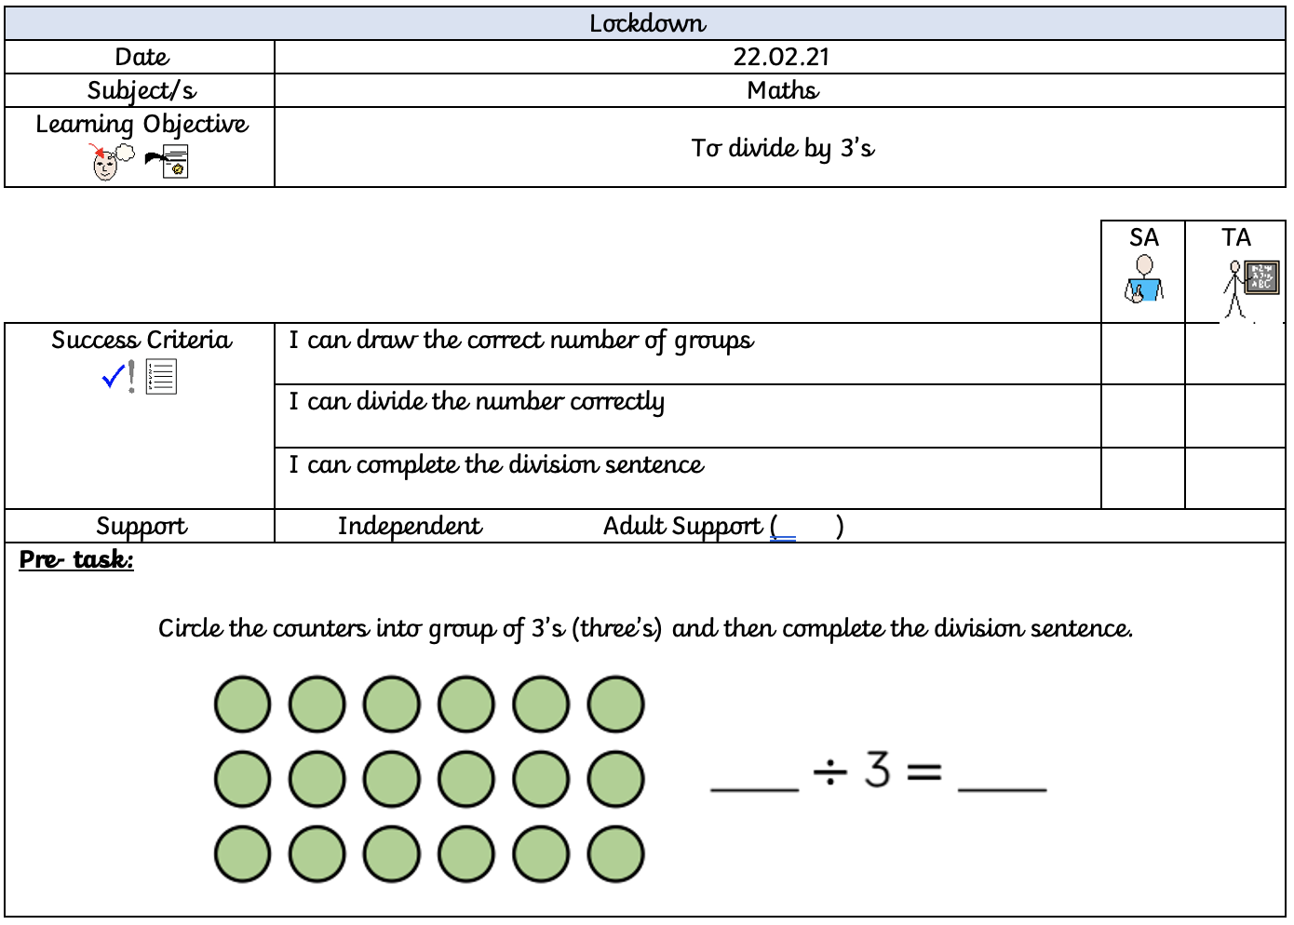
When dividing by 3, we share the given number into equal groups of three. For example:
Here is my group of three, and I have divided the number 9 into the circles by placing one cube into a group at a time.

This has then given me the answer of:
9 ÷ 3 = 3

Now have a go at drawing 3 big circles for each of these number sentences. Don’t forget to write the division next to it to show your answer.
18 ÷ 3 = | 21 ÷ 3 = | 33 ÷ 3 =
60 ÷ 3 = | 15 ÷ 3 = | 6 ÷ 3 =
12 ÷ 3 = | 42 ÷ 3 = | 54 ÷ 3 =

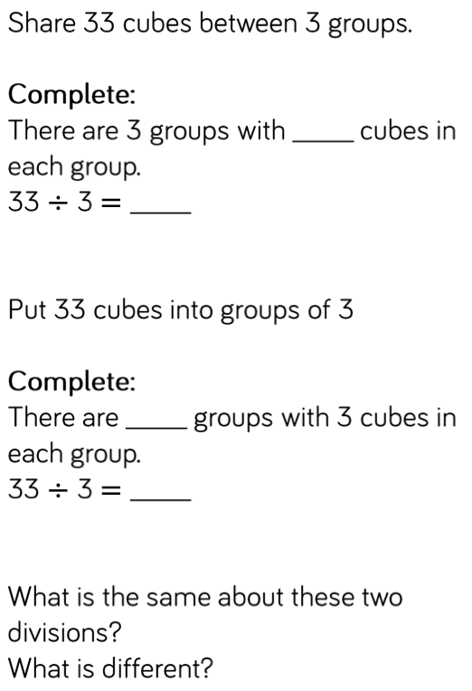
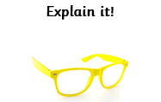
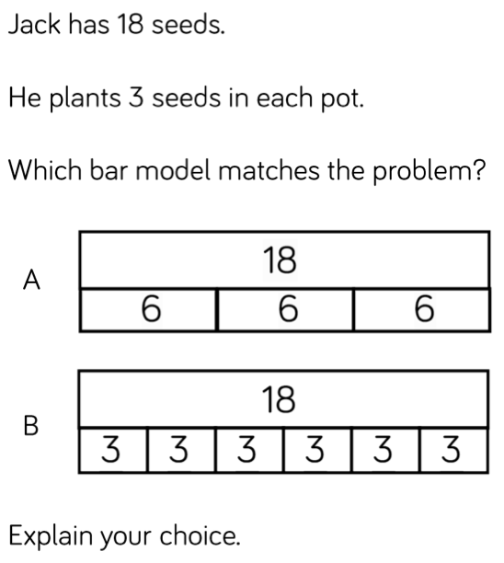
Draw out your groups.

