PSHE – Friday 5th March
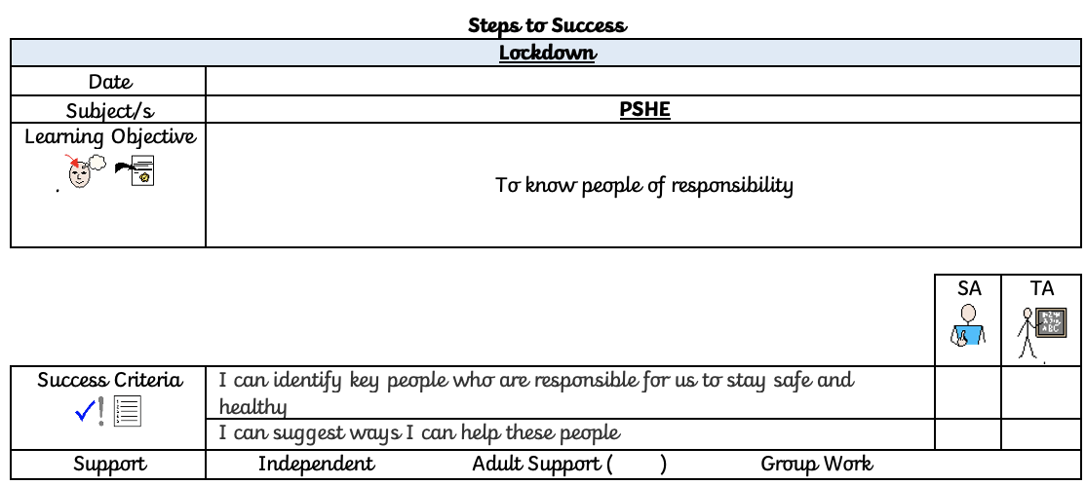
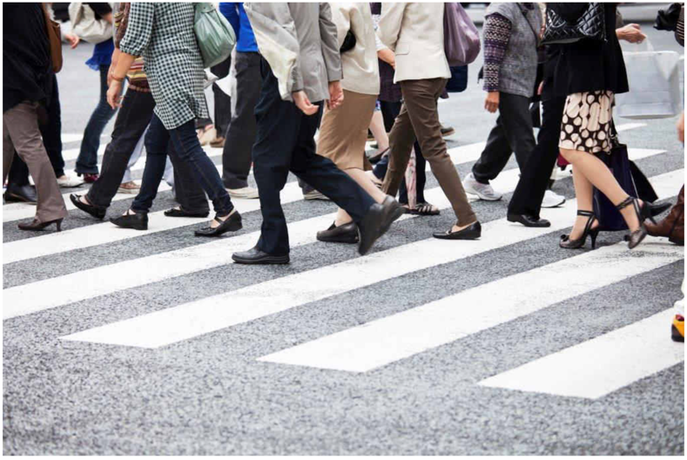
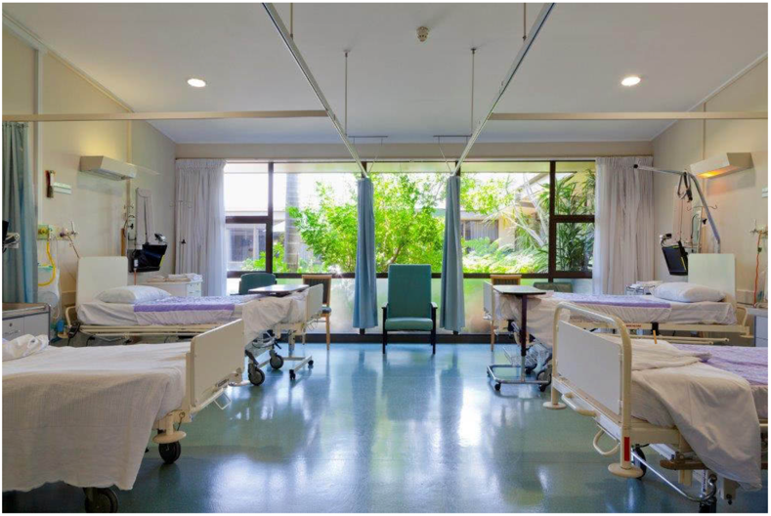

Look at these photos of the different locations.
- Where is this location?
- Have you been to this location?
- What is the location?

Discuss with your parent or sibling:
- Who helps us in these different place?
- Can there be more than 1 person who helps us?
- Who helps us in these places?
- How do they help us?
- Why do they help us?

YOUR TASK:
You need to draw a picture of yourself in one of these locations and also a picture of someone who helps you to stay safe or to be healthy in this location. For example, you could draw yourself and the lollipop lady at the side of the road, waiting at a crossing.
Once you have done your drawing, you need to draw a speech bubble and write two sentences starting with
‘I help you by…’

