Steps to Success
Lockdown
Subject/s | PSHE
Learning Objective  . | To identify risks of smoking and alcohol
 |  | SA | TA  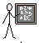
Success Criteria
 | 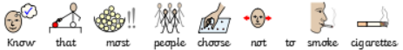
Support | Independent Adult Support ( ) Group Work
Sort the cards into the three columns
Alcohol | Cigarettes | Both

