Lockdown
Subject/s | Maths
Learning Objective | Multiply by 3
 |  | SA | 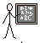  TA
Success Criteria | I can represent groups of 3
 | I can write the multiplication sentence
 | I can write the addition sentence
Support | Independent Adult Support ( )
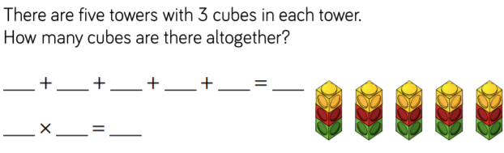
Pre- task:

Teacher led
Represent, write the multiplication and write the addition.
4 x 3

4 x 3 = 12
3 + 3 + 3 + 3 = 12
2 x 3

2 x 3 = 6
3 + 3 = 6

Draw the arrays, write the multiplication and addition for each of these
4 x 3 = 5 x 3 = 7 x 3 = 9 x 3 = 6 x 3 = 11 x 3 = 10 x 3 = 8 x 3 = 12 x 3 =

