Lockdown
Subject/s | Maths
Learning Objective | Multiply by 4
 |  | SA | 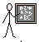  TA
Success Criteria | I can represent groups of 4
 | I can write the multiplication sentence
 | I can write the addition sentence
Support | Independent Adult Support ( )
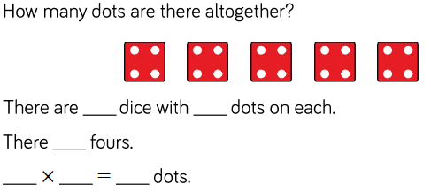
Pre- task:

Represent, write the multiplication and write the addition.
4 x 4

4 x 4 = 16
4 + 4 + 4 + 4 = 16
2 x 4

2 x 4 = 8
4 + 4 = 8
Draw the arrays, write the multiplication and addition for each of these
4 x 4 = 5 x 4 = 7 x 4 = 9 x 4 = 6 x 4 = 11 x 4 = 10 x 4 = 8 x 4 = 12 x 4 =

Problem Solving and Reasoning
