Lockdown
Subject/s | Maths
Learning Objective | Multiply by 6
 |  | SA | 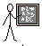  TA
Success Criteria | I can represent groups of 6
 | I can write the multiplication sentence
 | I can write the addition sentence
Support | Independent Adult Support ( )
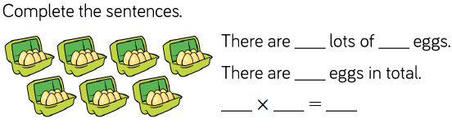
Pre- task:

2 x 6

2 x 6 = 12
6 + 6 = 12
4 x 6

4 x 6 = 24
6 + 6 + 6 + 6 = 24
Draw the arrays, write the multiplication and addition for each of these
4 x 6 = 5 x 6 = 7 x 6 = 9 x6 = 6 x 6 = 11 x 6 = 10 x 6 = 8 x 6 = 12 x 6 =

