Lockdown
Subject/s | Maths
Learning Objective | Multiply by 7
 |  | SA | 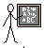  TA
Success Criteria | I can represent groups of 7
 | I can write the multiplication sentence
 | I can write the addition sentence
Support | Independent Adult Support ( )
Pre- task:
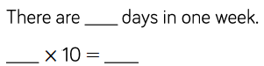

Draw the arrays, write the multiplication and addition for each of these
4 x 7 = 5 x 7 = 7 x 7 = 9 x 7 = 6 x 7 = 11 x 7 = 10 x 7 = 8 x 7 = 12 x 7 =

Problem Solving and Reasoning

Sara said that every number in the 7 times tables is odd, is she right?

Explain your answer

