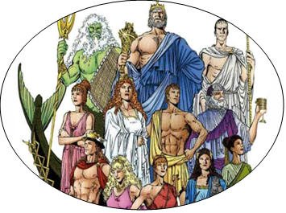
Homework Grid: Spring 1 – Gods and Mortals
Maths and English homework will be given out weekly, you must complete this.
The ideas below are optional, you can complete as many or as few as you would like. Remember there is also ‘MyOn’ and MyMaths to go on for additional maths and reading activities.
Design a mythical creature. Which animals’ body parts could you include? | Look at examples of pottery and create a design for an Ancient Greek jug or bowl. | Read about Nacissus, the young man who fell in love with his own reflection. What is the moral of the story?
Look carefully at the shapes of the letters of the Greek alphabet. Practice forming them and pronouncing them. | Spot buildings influenced by Greek architecture around your nearest town or city, and take photographs to show in school. | Taste some traditional Greek dishes such as mousakka, figs, goat’s cheese or taramasalata. Write a food review.
 | Find out about famous Greek philosophers such as Plato, Aristotle, Archimedes and Pythagoras. How did their work influence life today?

