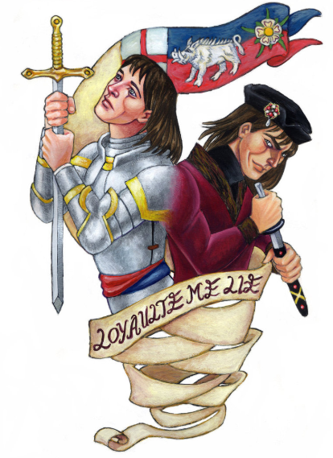
Homework Grid: Autumn 1 – Heroes & Villains
Maths and English homework will be given out weekly, you must complete this.
The ideas below are optional, you can complete as many or as few as you would like. Remember there is also MyMaths and MyOn to go on for additional Maths and English activities.
Collect stories from newspapers and magazines about everyday heroes, and make a clippings board. | Create a fact file about a real-life hero that you find interesting. | Sketch a portrait of your hero from photographs or images.
Take a trip to your local library. Use the books to find out about heroes and villains from past and present. | Make ‘Top Trumps’ cards for villains and heroes in children’s stories and fairy tales. | Imagine that you have performed a heroic act. Write a newspaper report about the act that you performed.
Make a list of five positive things that you and your friends could do to improve your school’s environment. | Write a set of instructions or a recipe that explains how to be, or what makes, a hero.

