Week commencing | Home Learning Set
2.9.21 | Begin to learn the spellings from our curriculum list:  https://firsprimary.derby.sch.uk/wp-content/uploads/2021/09/Year-3-and-4-Spelling-List.pdf
6.9.21 | Have a go at our problem Solving and Reasoning activity:  https://firsprimary.derby.sch.uk/wp-content/uploads/2021/09/Roman-Numerals-2.docx
13.9.21 | Maths – Writing numbers in words (see Home Learning book)  Discovering Languages – Can you sign your name?  https://firsprimary.derby.sch.uk/wp-content/uploads/2021/09/week-3.png
24.9.21 | 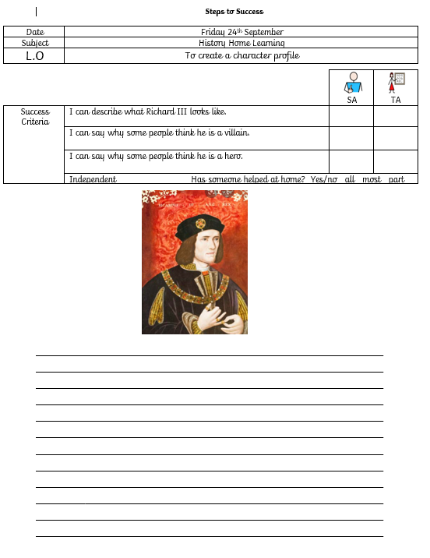
30.9.21 | MyMaths –  Your child has a log in already. See the guide on Dojo.

