Homework Grid: Spring 1 – Traders and Raiders
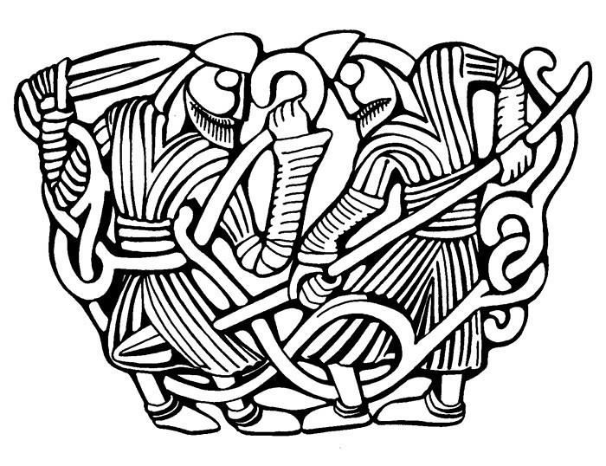
Maths and English homework will be given out weekly, you must complete this.
The ideas below are optional, you can complete as many or as few as you would like. Remember there is also MyMaths and MyOn to go on for additional Maths and English activities.
Visit your local library and find out about any Saxo or Viking invasions in your local area. | Try making Anglo-Saxon bread or Viking flatbread. | Look at images of Anglo-Saxon coins. Can you design a coin?
Do some research about Viking names and their meanings. | Research some simple Viking embroidery patterns. Could you make one yourself? | Look at the animals in Viking art. Can you design and draw an imaginary beast to make a pattern?
Find out more about the Futhark alphabet. Write a short message using the characters. | Imagine you are a Viking skald or poet. Create a poem to sing the praises of a friend. | Dress up in a typical Saxon or Viking costume.

