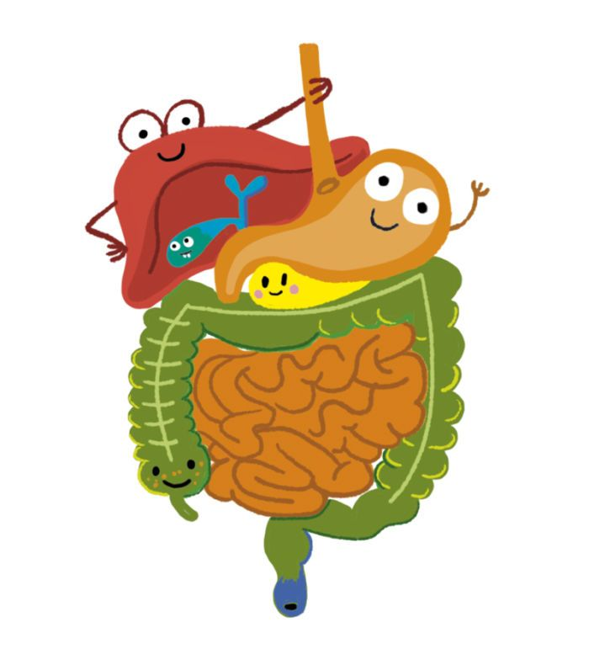
Homework Grid: Spring 2 – Burps, Bottoms, Bile
Maths and English homework will be given out weekly, you must complete this.
The ideas below are optional, you can complete as many or as few as you would like. Remember there is also MyMaths and MyOn to go on for additional Maths and English activities.
Keep a food diary and notice what happens as certain foods pass through your body. | Who spends the most time in the bathroom in your house? Display your findings on a chart! | Find out how to look after your digestive system with some colon-cleansing foods and make a poster to encourage people to look after their guts.
Learn how to boost your immune system. Make an advert for a doctor’s surgery to help people avoid getting flu. | Have a burping competition with family or friends! | Drop grubby copper coins into fizzy drinks and leave them overnight. What happens?
What qualifications and training do you need to become a dentist? | Some people sneeze because they are allergic to certain substances such as pollen or house dust mites. | Try a new food or drink that you have never tasted before?

